Process Decision

# 1. Reason:

According topic description and team SWOT, I found that :

* Major requirements is defined; however, some details still not.
* Requires new technologies.
* And our resources with needed skills are not available.
* There are some high risk features and goals.

So I think we should use Incremental process model for this project.

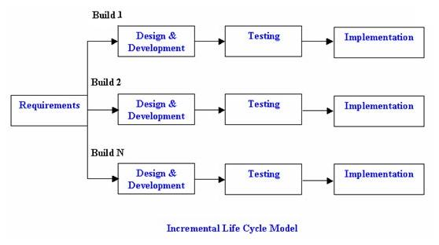

# 2. Advantages

* This model is more flexible – less costly to change scope and requirements.
* It is easier to test and debug during a smaller iteration.
* Easier to manage risk because risky pieces are identified and handled during it’d iteration.
* Each iteration is an easily managed milestone.
* We also have experiment about it.

# 3. Disadvantages

* Needs good planning and design.
* Needs a clear and complete definition of the requirement and system.